[CSA1011] - SOFTWARE ENGINEERING
NAME : DANIEL SAM K
REG NO: 192524081

- Create a Kanban Board to Visualize the Tasks.

- Create Columns for To Do, In-Progress and Done.
- Add Atleast 5 Sample Tasks
- Move the Tasks across the Columns to Simulate the Workflow.

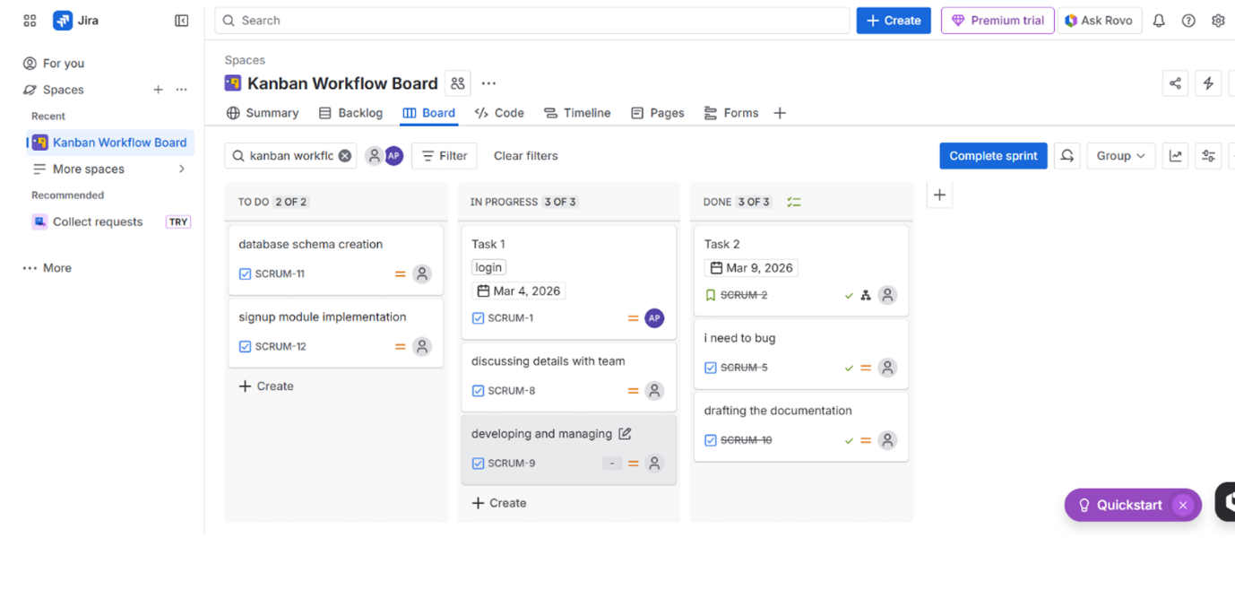

- Sketch a Simple Prototype of a Bus Ticket Booking System using Figma Tool
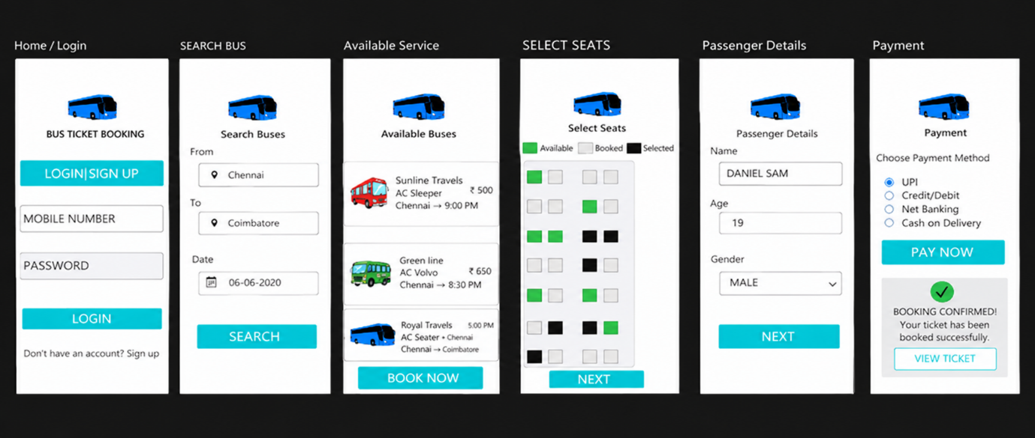

- The stakeholders have conflicting views on the user interface design
for an E-Commerce mobile app. Create a prototype using Figma tool
to discuss with the stakeholders to get their feedback and approval.
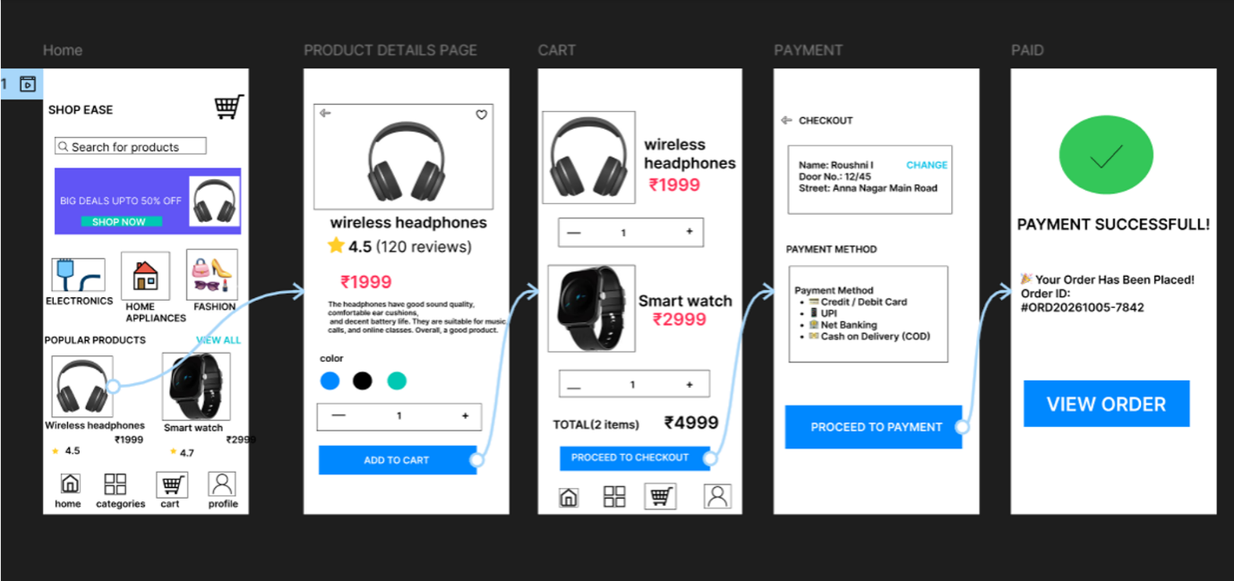

4. Create a Scrum Project in Jira.
- Add a backlog with at least 5 items (e.g., "Create user
- registration page", "Develop API for login").
- Prioritize the backlog and create a 1-week sprint.
- Move backlog items into the sprint and start the sprint.
- Finally show the Screenshot of the sprint board at the start and
- end of the sprint.

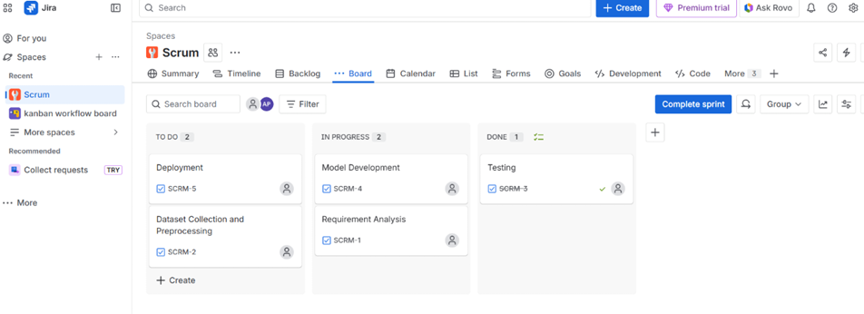

5. Use the following requirements for a Library Management System:
- Add a feature to search books by title and author.
- Implement an online book reservation system.
- Generate monthly reports on borrowed books for
- administrators.
- Enable email notifications for overdue books.
- Add support for QR code scanning for borrowing and
- returning books.
- Create a user-friendly dashboard for librarians.
- Allow users to review and rate books.
- Integrate a chatbot for user assistance.
- Develop a mobile app version of the system.
- Provide multi-language support.
- Categorize each requirement using MOSCOW Method (Must-Have,
- Should-Have, Could-Have, or Won’t-Have) based on the following
- criteria:
- Impact on the users and stakeholders.
- Feasibility considering time, budget, and resource constraints.
- Finally Submit the completed Google Sheet or Excel file with all
- requirements categorized and justified.

